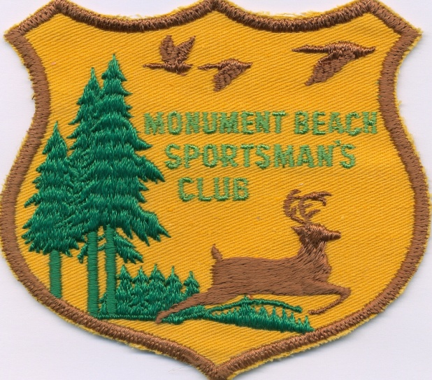

MONUMENT BEACH SPORTSMAN’S CLUB
‘ALCOTT TOBEY SCHOLARSHIP’ APPLICATION

MBSC offers this scholarship to encourage young men and women to continue their education at a college, university or vocational school of their choice. Scholarships will be awarded to approved applicants that meet the following criteria:
SCHOLARSHIP APPLICATION CRITERIA

- Applicant must be a high school senior, or currently enrolled in a “higher education” institute as listed above and have not completed their course of study. Applicant may reapply in future years.
- The minimum GPA required to be considered for this scholarship is 2.5 GPA on a 4.0 GPA scale. Please attach a current transcript to application.
- MBSC will award a maximum of $1500.00 per year, in increments of $500.00 per scholarship; however the club need not make an award in a particular year if committee deems there are no approved applicants. Likewise, this represents a total amount awarded and the value of any scholarship may vary year to year.
- Applicant must either be a Massachusetts Resident, or may live outside of MA if they are a relative of a current MBSC member. PLEASE NOTE: It is not a requirement that the applicant attend a school within Massachusetts.
- Scholarship awards will be paid directly to the school or may be paid to the applicant in the form of reimbursement IF they have already made payment to the school and with verification of paid receipt. Paid receipt must be dated after any award has been made and is not valid for prior payments.
- All criteria are subject to consideration by the Scholarship Selection Committee. Committee is not responsible for any applications not received. Award selection to be made NLT April 30th.

IT IS YOUR RESPONSIBILITY TO ENSURE THAT THE APPLICATION IS RECEIVED, POSTMARKED BY APRIL 1ST, 2023. SEND COMPLETED APPLICATION TO:

MBSC
ATTN: SCHOLARSHIP SELECTION COMMITTEE
PO BOX 331
MONUMENT BEACH, MA 02553

Any questions pertaining to this scholarship can be emailed to: mobeachsports@gmail.com

______________
Applicants Initials
MBSC ‘ALCOTT TOBEY SCHOLARSHIP’ APPLICATION

APPLICANT’S NAME: ____________________________________________________________
PARENT’S NAME: ______________________________________________________________
STREET ADDRESS: _____________________________________________________________
MAILING ADDRESS: _____________________________________________________________
HOME PHONE: ___________________________ BIRTH DATE: _______________________
EMAIL ADDRESS: _______________________________________________________________

ARE YOU OR ANY OF YOUR FAMILY A MEMBER OF MBSC? IF SO, PLEASE LIST NAMES:
_________________________________________________________________________________________

- SCHOOL: Name of High School: _________________________________________________________
Scholastic Average: ________________________ Graduation Date: ____________________________
Name and Address of College, University or Vocational School Now Attending or Planning to Attend:
______________________________________________________________________________________
Anticipated Major: ______________________________________________________________________
Undergraduate GPA (If Applicable): __________________
**Be sure to enclose a copy of latest transcript.

- EXTRACURRICULAR ACTIVITIES: Briefly state major involvement in community activities such as church, sports, service clubs, outdoor pursuits, etc.
____________________________________________________________________________________
______________________________________________________________________________________
______________________________________________________________________________________

- REFERENCES: A minimum of two letters of recommendation should be attached. At least one letter should come from any of the following sources: Teacher, Professor, Pastor, Minister, Rabbi, Employer or Volunteer Coordinator.

- WRITE A 500 WORD ESSAY (Single Page): Essay should explain reason applicant is requesting scholarship and how it will assist them in their pursuit of higher education. Any special circumstances such as financial considerations or obstacles the candidate has overcome should be included for consideration.

***APPLICANTS WITHOUT ALL REQUESTED MATERIALS LISTED ON BOTH PAGES WILL BE DEEMED INCOMPLETE AND MAY BE INELIGIBLE FOR CONSIDERATION. APPLICATIONS RECEIVED, POSTMARKED, AFTER APRIL 1ST WILL BE INELIGIBLE FOR REVIEW. ALL APPLICATIONS, PICTURES, TRANSCRIPTS BECOME THE PROPERTY OF MBSC AND WILL NOT BE RETURNED.

***WINNER(S) WILL BE ANNOUNCED VIA DIRECT EMAIL TO RECIPIENT, FOLLOWED BY LETTER VIA US POSTAL. INSTRUCTIONS ON RECEIPT OF SCHOLARSHIP WILL BE EMAILED TO THE RECIPIENT(S).

I have personally prepared this application and certify it to be correct.

Date: _____________________________ Applicant Signature: ____________________________________

NOTE: Please return BOTH PAGES and make sure to initial bottom of 1st page.

