

The Monument Beach Sportsman’s Club is proud to present a

Women’s Only instructional shooting clinic.

Sunday, May 18, 2025

**7:45 am** to 5:30pm

At

The Monument Beach Sportsman’s Club

199 MacArthur Blvd

Bourne, MA

**Event is SOLD OUT**

Ladies - if you’ve ever thought about trying your hand at recreational shooting, here is your opportunity! Come join us for a women’s only instructional shooting clinic. You will receive hands-on instruction in shotgun, rifle, pistol and archery by the friendly and knowledgeable folks at the Monument Beach Sportsman’s Club. All women are invited to participate regardless of skill level. No previous experience is necessary - just the desire to learn and have fun. For those interested in applying for a Massachusetts firearm license, this class will qualify you to receive your certificate allowing you to apply for a Firearms Identification Card (FID) or your License to Carry (LTC) upon completion of the day.

All equipment and student texts are included. Lunch and refreshments will be served!

This event fee $75.00 per person and is limited to 50 people. You must be at least 16 years old to participate. **REGISTER EARLY – THIS CLASS ALWAYS FILLS QUICKLY AND NO WALK-INS ARE ALLOWED**.

Have questions? - contact Emily Machado @ emilymachadombsc@gmail.com

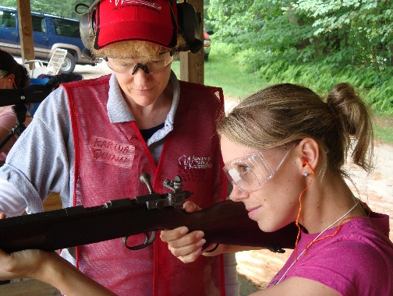

The 2nd Amendment is *An Equal Opportunity Civil Right*